**PHASE 5**

**LESSON 4**

**PRACTICE ASSISTED 3**

**Container Deployment Using Docker Swarm.**

**CODE:**

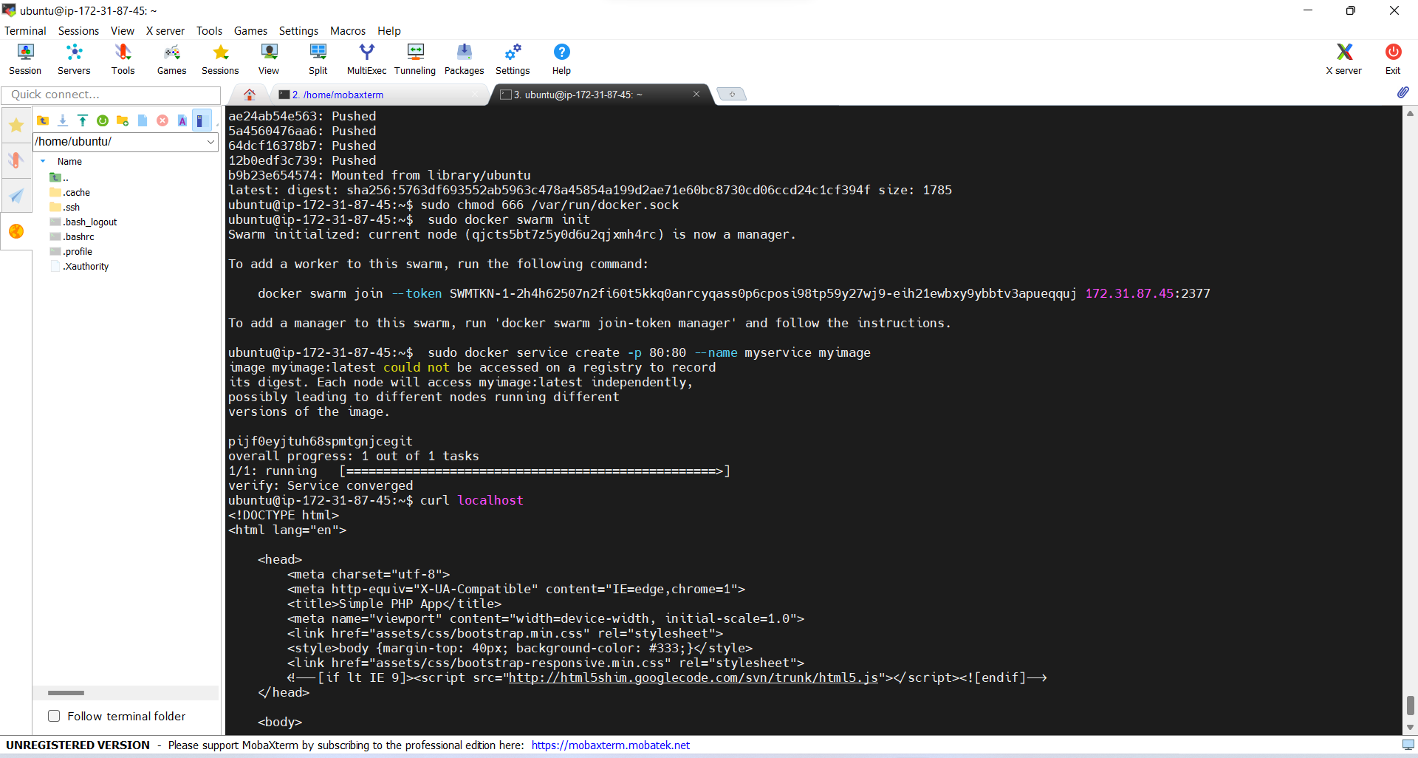

**OUTPUT:**

